**EXPLORING ACADEMY**

**Trends in Startup**

DPP 4

SUBMITTED BY :

SHUBHANGI GOEL

MBA 1ST SEM

**TASK:-**

1. **Calculate the total number of companies in the dataset.**

**QUERY:**

SELECT count(name) FROM "TrendsInStartups_Explorin"

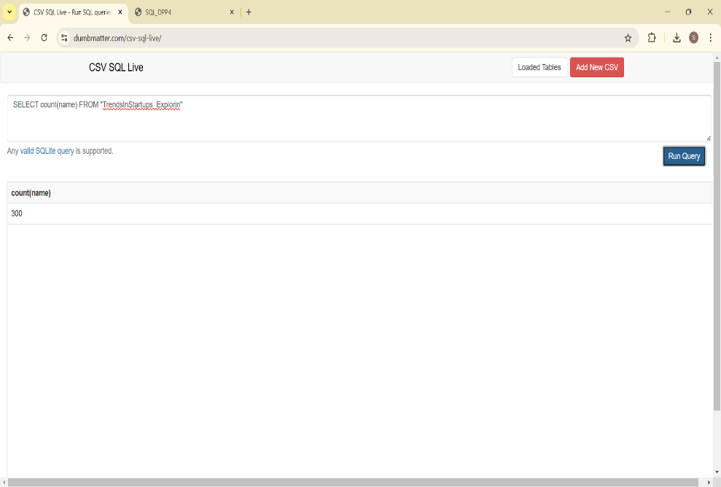

1. **Determine the total value of all companies in the dataset.**

**QUERY:**

SELECT SUM(VALUATION) AS total_valuation FROM "TrendsInStartups_Explorin"

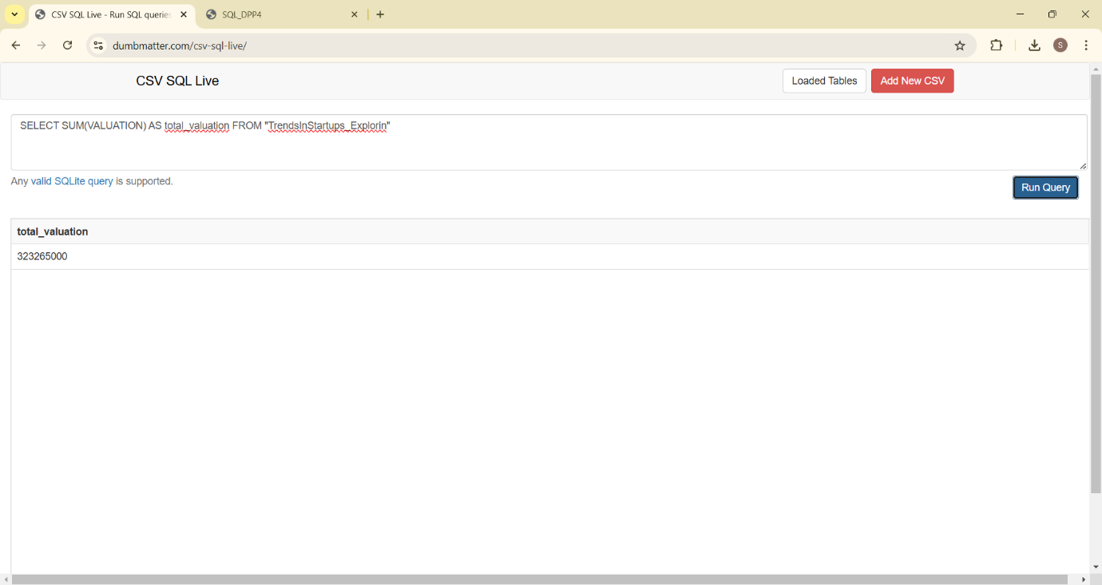

1. **Find the highest amount raised by a startup at the 'Seed' stage.**

**QUERY:**

SELECT MAX(amount_raised) FROM "TrendsInStartups_Explorin"

WHERE stage = "Seed"

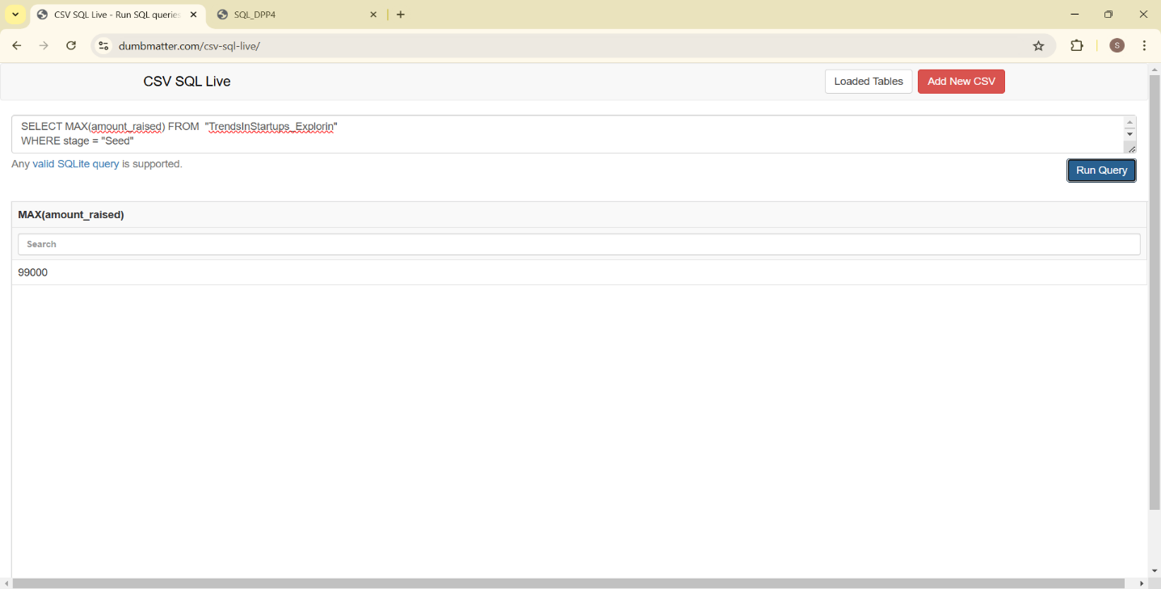

1. **Identify the year when the oldest company on the list was founded.**

**QUERY:**

SELECT min(founded_year) FROM "TrendsInStartups_Explorin"

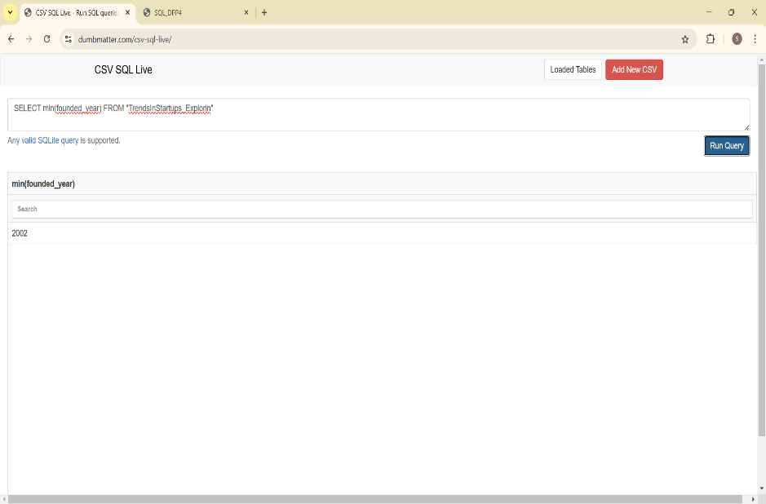

1. **Calculate the average valuation within each startup category**

**QUERY:**

SELECT avg(valuation) FROM "TrendsInStartups_Explorin"

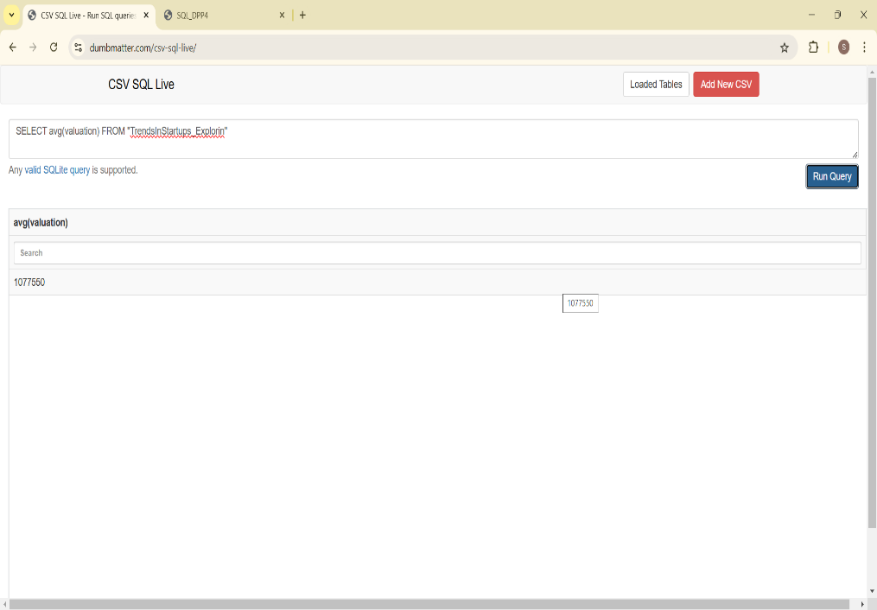

1. **Determine the top locations with the highest number of startups.**

**QUERY:**

SELECT location, count(*) as startup_count FROM "TrendsInStartups_Explorin"

group by location

order by startup_count desc

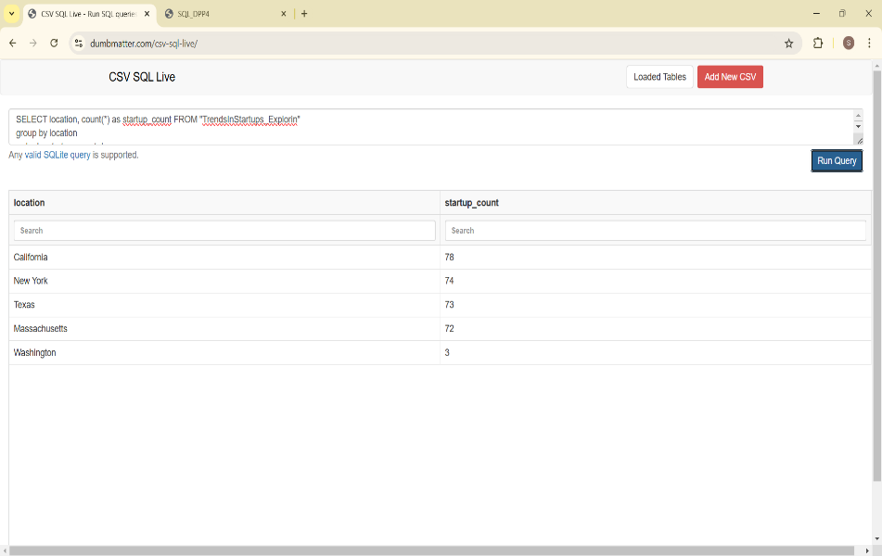

1. **Calculate the average size of startups in each location where the average size exceeds 500.**

**QUERY:**

select location, avg(size) as avg_size from TrendsInStartups_Explorin

group by location

having avg_size > 500

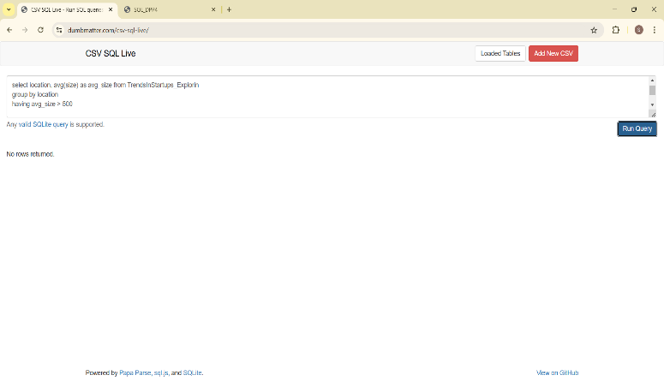

1. **Find the top 5% of startups with the highest valuations.**

**QUERY**:

select name, valuation as hightest_valuation from TrendsInStartups_Explorin

group by name

having hightest_valuation

order by hightest_valuation

limit (SELECT COUNT(*) * 0.05 FROM TrendsInStartups_Explorin)

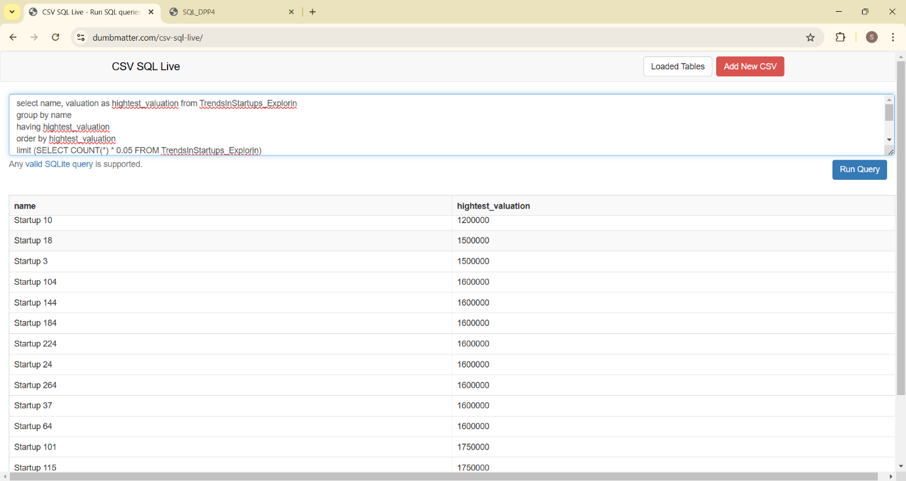

1. **Identify startups that have raised funding in every stage (Seed, Series A, Series B, etc.)**

**QUERY:**

select name, stage from "TrendsInStartups_Explorin"

where Stage = "Seed"

and Stage = "Series A"

and Stage = "Series B"

and Stage = "Series C"

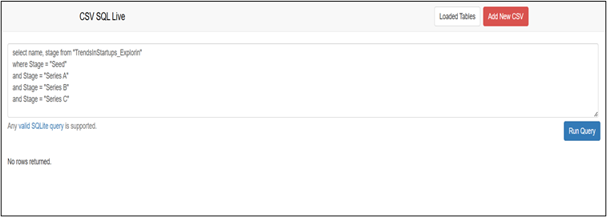

1. **Calculate the percentage growth in valuation from Seed stage to Series A for each startup.**

**QUERY:**

Select B.name, B.id, ((B.valuation-A.valuation)*100/A.valuation) from TrendsInStartups_Explorin A

Join TrendsInStartups_Explorin B

On A.name = B.name

AND A.stage = "Seed"

AND B.stage = "Series A"

